Directions: complete the following questions in your notebook.

Impact of the First World War
Source A: The Treaty of Versailles, 1919
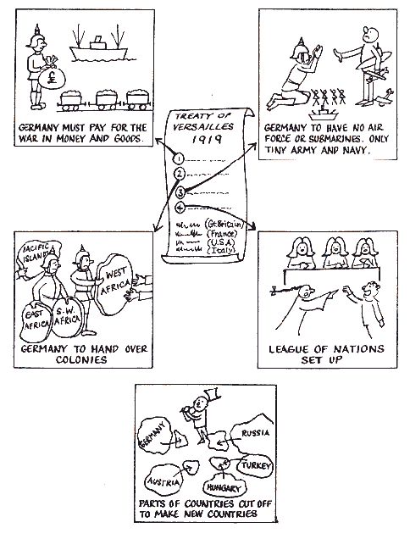

*Since Germany lost, they were forced to sign the treaty.

- What is Germany required to do under this treaty.
- Explain how Germany is treated in this treaty?
- What does the author suggest of the allies’ feelings toward Germany?

Impact of the First World War
Source B: A British Cartoon that appeared in a newspaper in 1919.
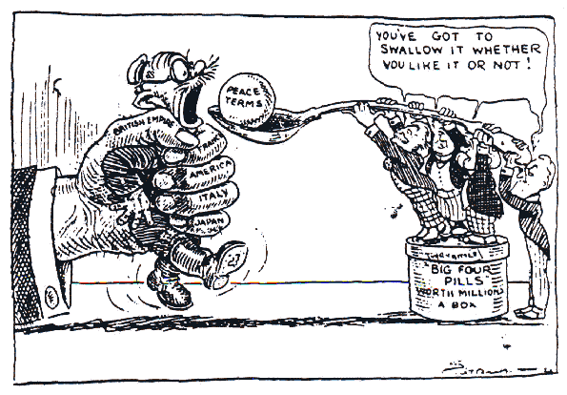

- Which figure was supposed to be Germany?
- Describe the literal manner in which Germany is treated in the cartoon?
- In a broader sense, how is Germany being treated?
- What is the motive behind this cartoon?

